

Expression of Interest Form

**DONEGAL Town & Village Renewal Scheme 2023**

**Submission Date before: 2pm Wednesday 6th September 2023**

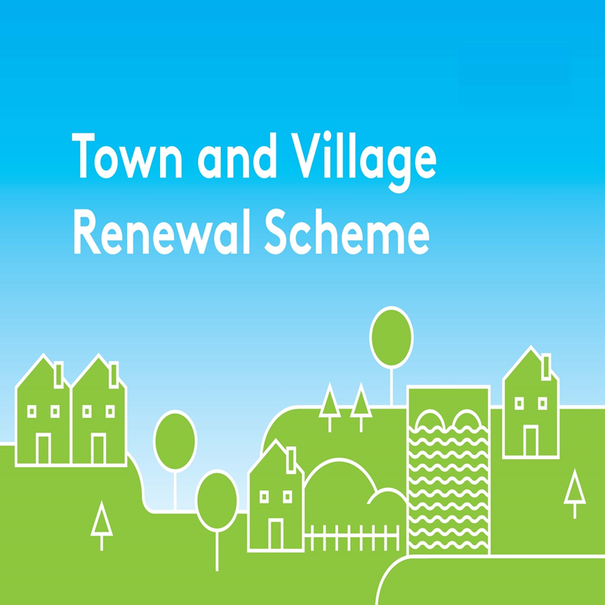

Please complete this Expression of Interest

and return it to Donegal County Council at [TownandVillage@donegalcoco.ie](mailto:TownandVillage@donegalcoco.ie)

**Town & Village Renewal Scheme 2023**

**Town/Village covered:**

**Please indicate which category of funding is being applied for:**

**Category 1 Category 2 Category 3**

**Towns/Villages with Towns/Villages with Towns/Villages with**

**Population of 5,000 Population of Population up to**

**or less 5,001-10,000 15,000**

**Amount of Funding Requested:**

**Applicant Group:**

**Applicant Contact Name:**

**Applicant Contact Address:**

**Applicant Telephone Number:**

**Applicant Mobile Number:**

**Applicant Email Address:**

1. **Has funding for this project ever been sought from other sources?**  Yes  No

**(If "YES" yes please specify from what source and if funding was provided)**

|  |
| --- |
|  |

1. **Who are the specific project stakeholders/community partners in this project?**

**(Chamber of Commerce, Community group, etc.).**

|  |
| --- |
|  |

1. **Project details:**

|  |
| --- |
|  |

1. **If seeking funding of between €250,000 and €500,000, please detail the particular case for this level of funding.**

|  |
| --- |
|  |

1. **What is the objective of the proposed project and how will the intended outcomes be measured? (Please identify any metrics or benchmarks that will be applied).**

|  |
| --- |
|  |

**DECLARATION**

|  |
| --- |
| **I hereby confirm that I have read and understand this document. I request that consideration be given in support of the project as outlined above.**  **Signature __________________________________________________**  **Position __________________________________________________**  **Date __________________________________________________** |

**CLOSING DATE FOR RECEIPT OF EXPRESSIONS OF INTEREST:**

**2pm Wednesday 6th September 2023**

Completed EOI’S should be returned by e-mail to [TownandVillage@donegalcoco.ie](mailto:TownandVillage@donegalcoco.ie) **before 2pm on Wednesday 6th September 2023**

**Late Expressions of Interest will NOT be considered.**